DATABASE MANAGEMENT SYSTEM

LAB ASSIGNMENT

DATABASE USED: mySQL

NAME: MOHD AMIR AHMAD

CLASS: B.TECH(Comp. Engg.)

ROLL NO-: 11CSS35

1)Table 1- EMPLOYEE135

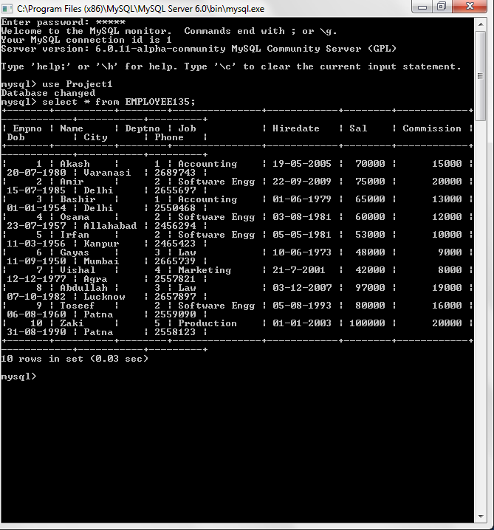

2)Table 2-DEPARTMENT135

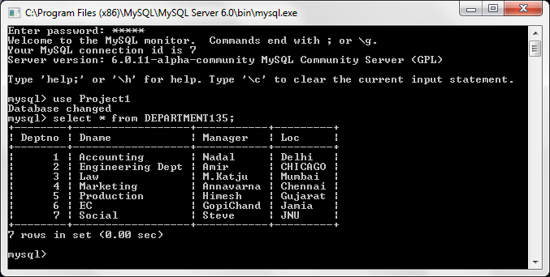

3)Table 3-SALARY135

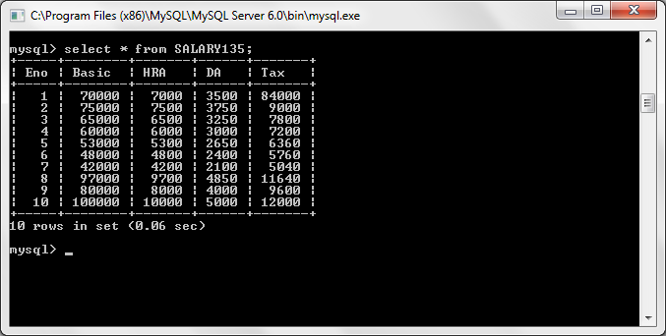

1. **Get the name and city of the employee working for the accounting department?**

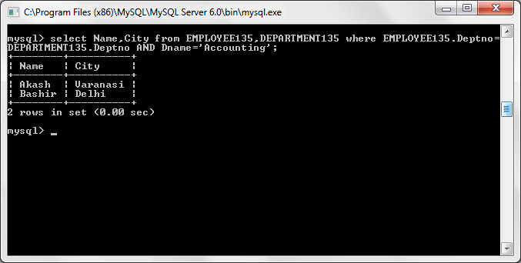

1. **Get the name, department name of all the employees whose pay is greater than 10000.**

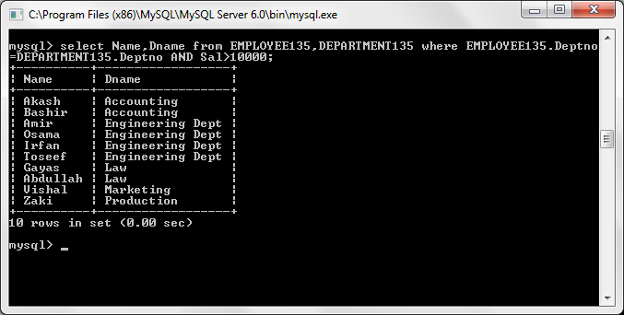

1. **Get the name of the employee in ascending and descending order.**

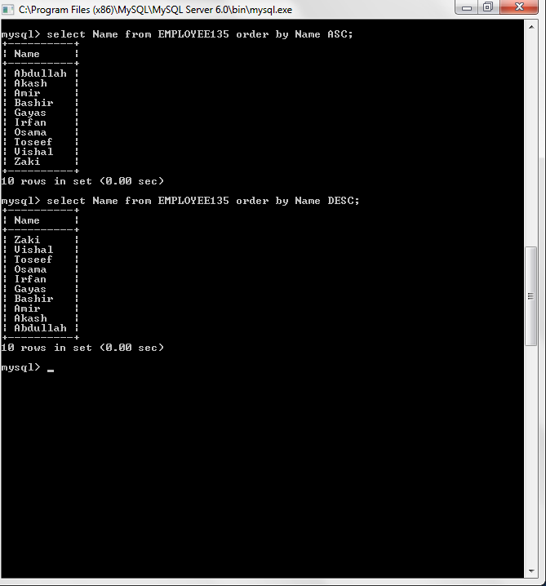

1. **Update the city of the employee no.2 from Mumbai to Delhi.**

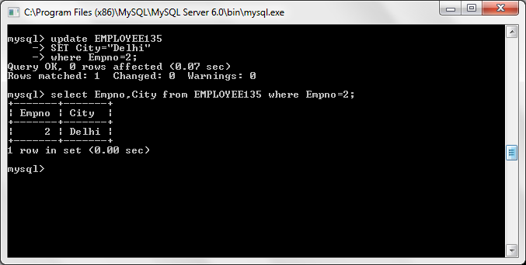

1. **Get the sum of the basic salary of the employees belongs to Delhi city.**

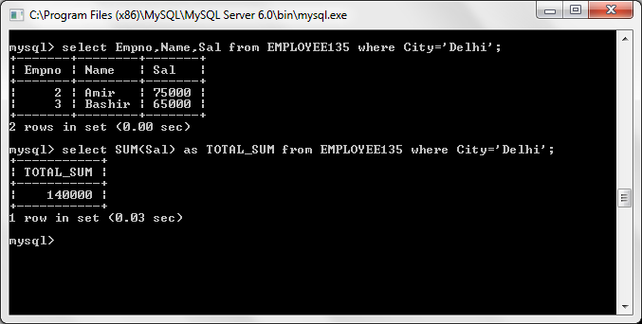

1. **Get the details of the highest income tax payee.**

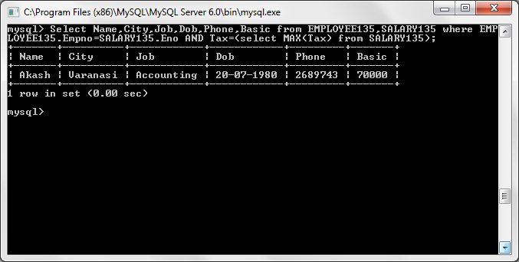

1. **Which employee is the senior most?**

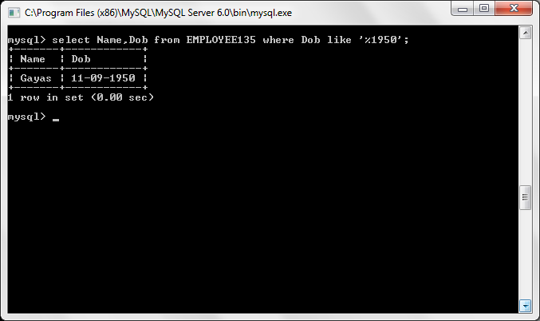

1. **Give the details of second highest salary employee (without use of �<� operator)**

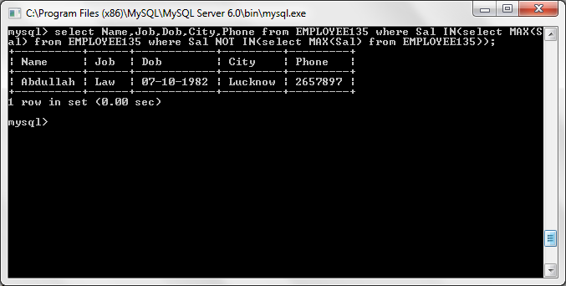

1. **Give the details of second highest salary employee (without use of max and limit operator)**
2. **Give the details of second highest salary employee (with the use of MINUS operator)**
3. **Give the details of all employees of 6th highest salary ( or nth highest salary)**

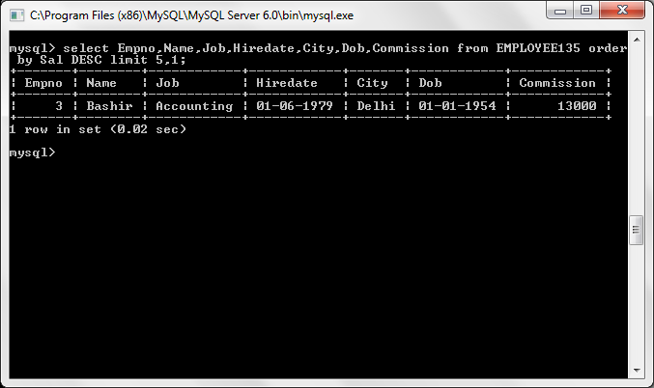

1. **How many clerks are there in the company?**

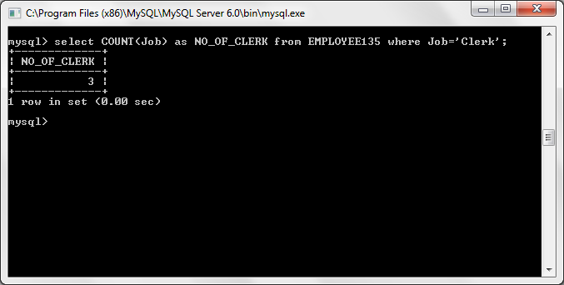

1. **Which department has exactly one employee as clerk?**

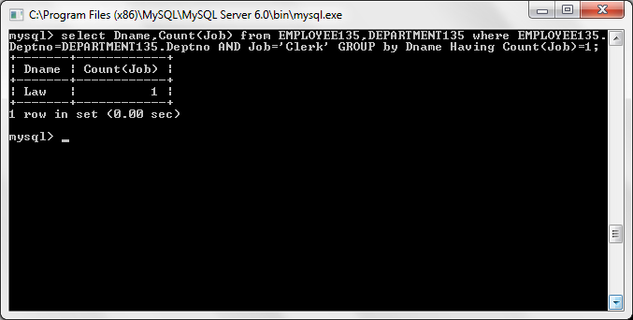

1. **Which department has the highest number of clerks? Show the deptno and count.**

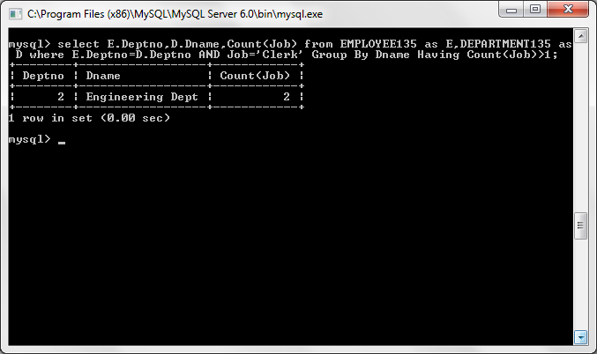

1. **How many employees are there in each department?**

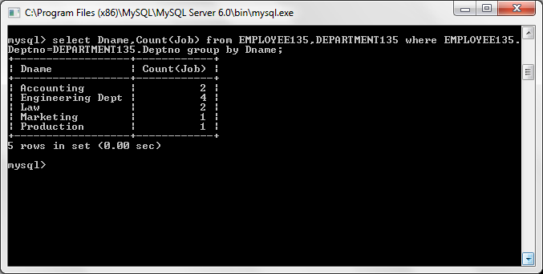

1. **List the lowest salary for different jobs used in a company and list them in descending order.**

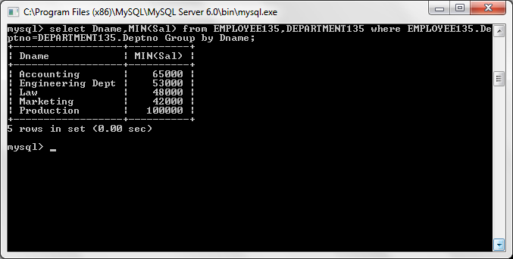

1. **Which department average salary is the lowest among all? Show the deptno,average salary.**

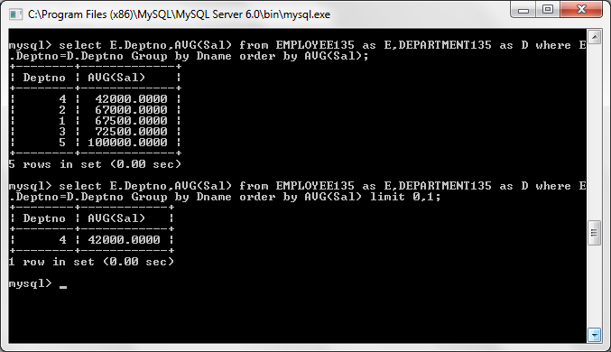

1. **List the minimum, maximum and average salary for each job.**

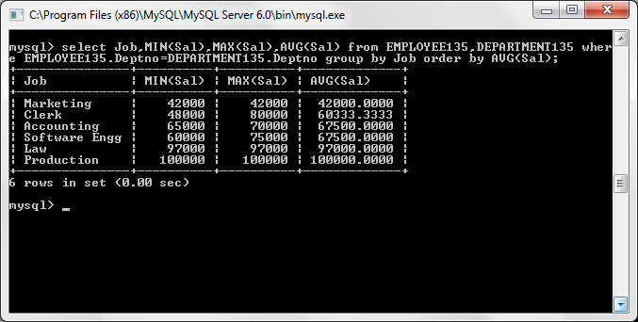

1. **Compute the difference between maximum and minimum salary**

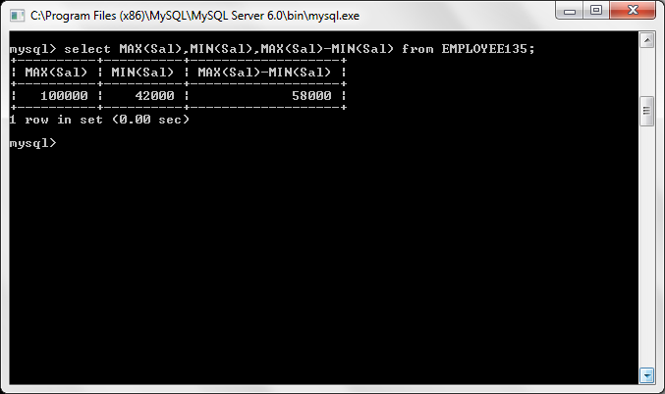

1. **List the names of the employees whose name contains LA.**

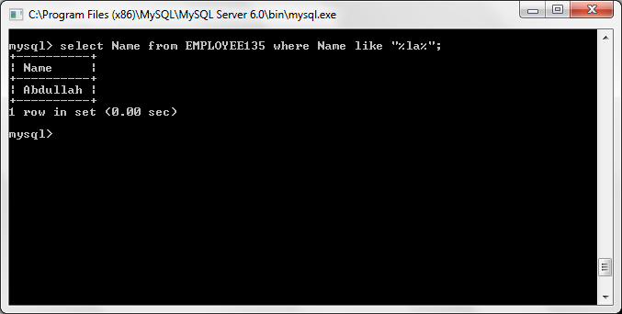

1. **List the names of the employees whose joining date is between 2nd April,1981 and 8th Sept,1981.**

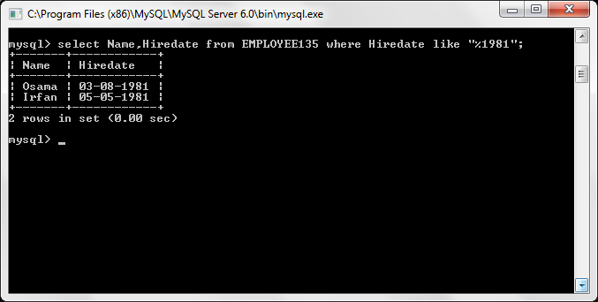

1. **How many different job titles exist in the employee table?**

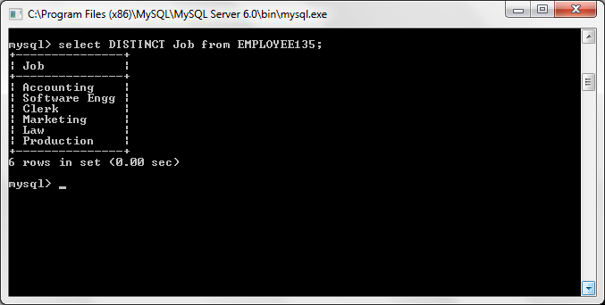

1. **Compute the sum of all salaries of employee working under deptno=30**

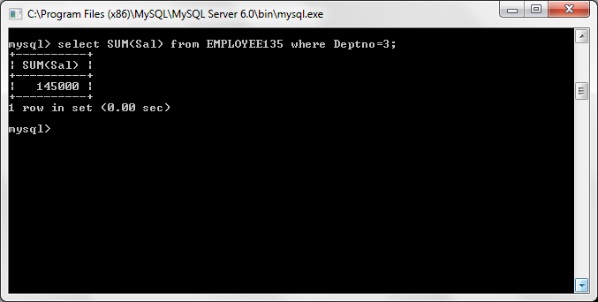

1. **For each salesman in the emp table retrieve the deptno and department name.**

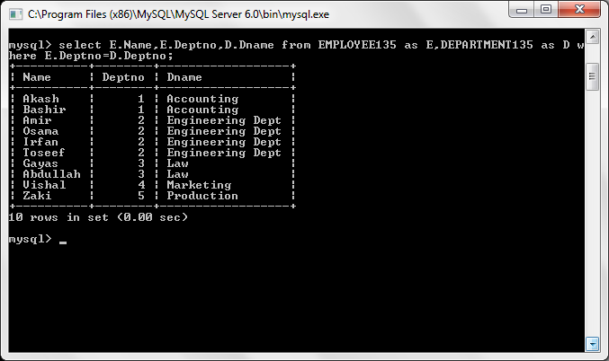

1. **List the names of all the employees with their name of the manager.**

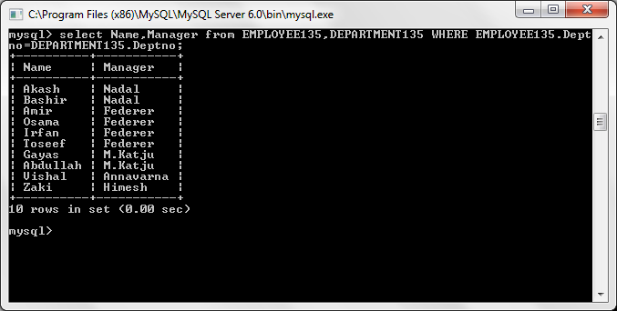

1. **List all employees who are working in department located at CHICAGO.**

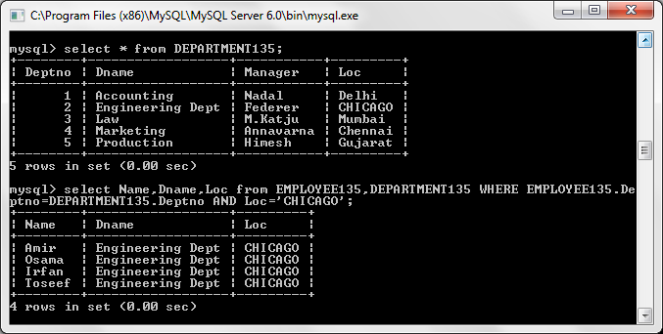

1. **List all the employees who are working in same department as their managers.**

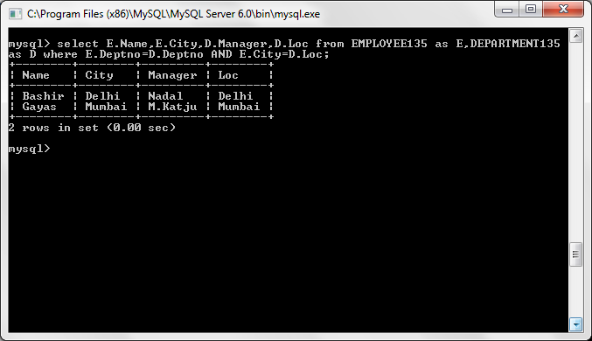

1. **Retrieve all the employees who are working in deptno=10 and who earn salary atleast as much as any employee working in deptno=30.**

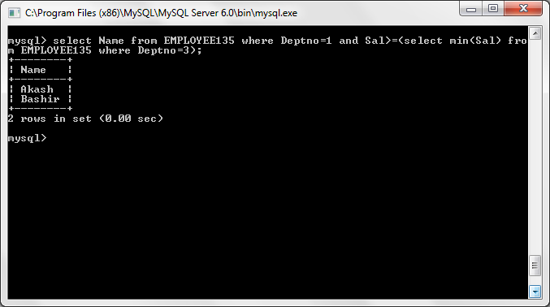

1. **List all the department who have no employees**

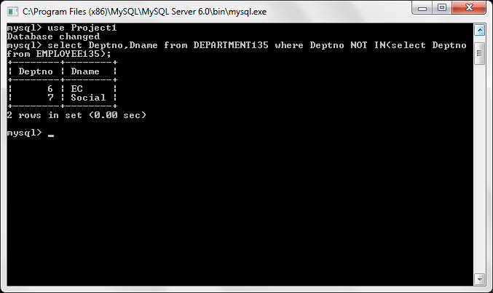

1. **Delete the EC department.**

